# Database Design Requirements

## Client: Carlotta Antique Jewelry

Document Prepared By: Dyfan Batchelor

## Requirements brief

As it stands, the current system being used to record sales data will become over whelming and difficult to read as human error begins to tarnish the integrity of the data. As such, an automated database system for recording sales and storing all related data would be the most efficient direction for the business moving forward, as this would take a lot of the work you need to do out of your hands.

The automated system I suggest is one developed using Microsoft SQL Server. Microsoft SQL Server will allow the creation of various tables for storing specific data (i.e. Customer data, the category they belong to and whether they wish to receive the newsletter). Much of this information will only need to be entered once, incredibly useful in the case of returning customers.

The automation side of the database will allow the generation of sales reports, automated newsletter send out, price calculation and more, meaning less time spent on organizing and sorting through your data, and more time selling.

As the database will hold information such as transactions and customer data, security is paramount. Roles can be given to specific users of the data base that dictate their overall access to the database, some of these roles may include;

* System Administrator: can add, update, delete and read rows from **all** tables
* Sales Staff: can add, update, delete and read rows only from the *Customers* and *Sales* tables
* Customer Relations Staff: can read data from all tables

## Entity relationship diagram

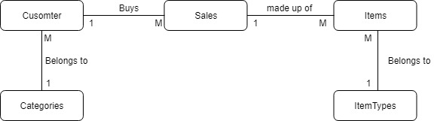

## Normalisation issues

1. There are two John Smiths with the same address but the capitalization is wrong

1. There are two Surry Hills address’ with different postcodes
2. In the Sales table, Item 1 has not been filled out but item 2 has been filled out for example

1. There are inconsistencies in the categories section (for example; 40-49 and 40-48)

1. Send news letter has an empty cell (It should default to no)

1. The data in year 3 and price 3 are swapped

## Database diagram

